Contributor Guidelines
The Medisys EduTech Medical Education (MEME) unit presents this exciting platform for you to showcase your expertise by presenting case-based discussions [CbD]. We invite you to subscribe to this educational venture from MEME and contribute to our cherished dream of life-long learning!
MEME offers short and medium term courses, as well as credit-based CMEs, to practicing family physicians in an online medium of digital education. The curricula are built to lead students to certification with post-graduate programs.
This communication is to support you, as the Case Authors, in your contribution of invaluable time to upload, submit and review high-quality CbDs here.

What are Case-based discussions?
Case-based discussions [CbDs] are proven clinical scenarios that simulate findings from live patients, but on an online platform, allowing students to develop their clinical reasoning & instincts. CbDs are online programs that mimic real-life clinical situations encountered by doctors in their day-to-day workplace/ practice. They essentially derive their strength from branching logic, where a simulated situation teases the student with a strategic decision-taking question, which in turn decides the next course of action as well as what follows and sometimes the final outcome also. This process, which might well be called a decision tree, exposes students to real clinical situations that challenge their clinical acumen, without itemizing them [like history-taking, general, physical and systemic examination, investigations and so on,] which is more an academic undergraduate requirement.
Each scenario offers an opportunity for students to test their clinical reasoning skills and thus experience the consequences of each decision. A decision taken earlier might either have a serious implication or a good prognostic value in the final outcome of the case.
Students are advised to complete the scenarios individually and then discuss the case in more detail in the digital classroom [the discussion forum available in the online platform], comparing their answers and the reasoning which led to them.
The rationale of this tool, is that it teaches the students the ‘whys’ of decision-making; it also lets them see for themselves how their decisions impact the outcome, which relates well with critical thinking when caring for patients. This in a way resolves the challenge that online education faces in terms of enhancing hands-on skills and tends to dissolve the myth that online education can/does not augment clinical skills.

Clinical Case submission
Case-based scenarios can be submitted in one of the two categories, depending on the target audience, viz.
- One for undergraduate medical students, who at present are un-initiated in patient care, and unaware of the standardized and universal clinical case presentation; (Annexure 1)
- The second category for the medical graduates medical officers who are already into practice or service and have some own healthcare experiences, which can either challenge the content presented or supplement their own learnings from the CbDs ; (Annexure 2)
  - The learning experience for the students has to be in tune with requirements of such practitioners, as those who may be public health professionals with very little clinical exposure, or rural health practitioners with limited resources to update their knowledge or aged practitioners who have little stamina to read through volumes of text.
- Ask yourself
  - How would this case scenario connect with what the student already knows or does?
  - How would this case scenario challenge the learner’s understanding and his/her practice?
Case submission proposal
Steps to be followed
- Facilitating submission of a proposal
  - Case submission starts with free Registration of the Case Author (with a pre-defined form), followed by submission of a case proposal. The Case Author who intends to submit a case needs to fill up the Case Submission Proposal form, Fig. 1.
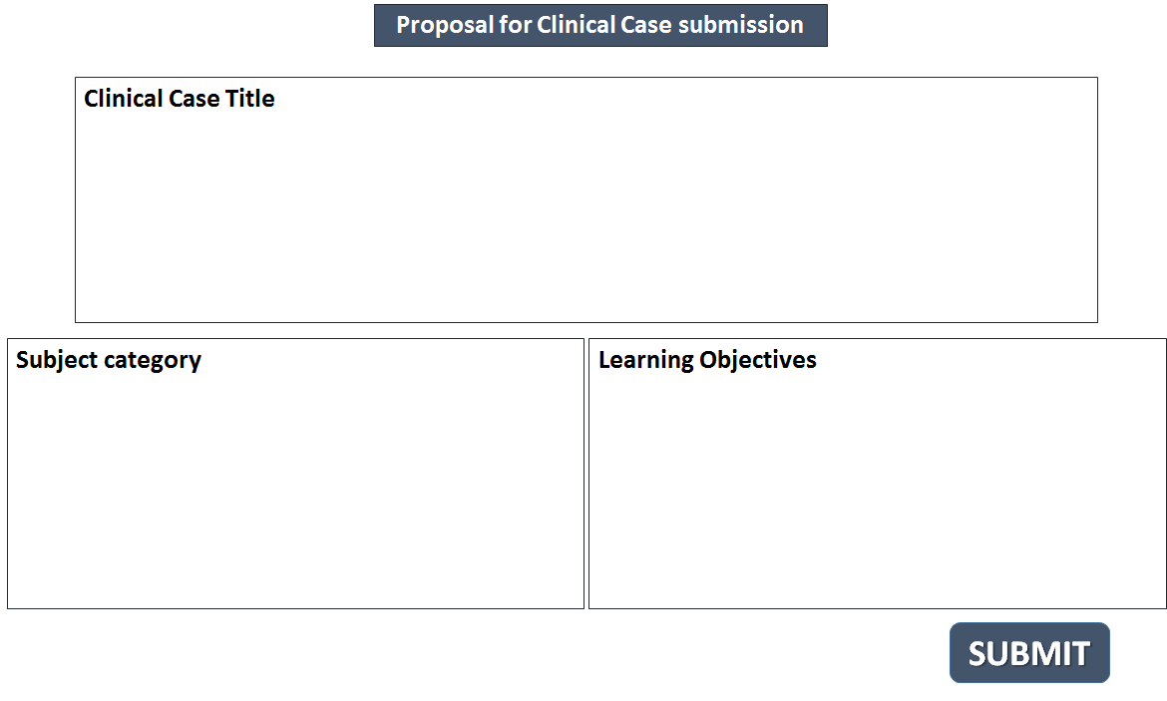

Figure 1: Case submission proposal form

The Case Author needs to submit the proposal for the case study under the following heads: Clinical Case Title, Subject Category and the Learning objectives.
  - Currently, the Subject category includes these options: Family Medicine, Diabetes, Pediatrics and Cardiology.
  - The case author shall specify the category/ sub topic for which their submission is intended.

- Review of clinical case proposal by the MEME Academic Board
  - MEME Academic Board, comprising the Course Director for the subject area and the Academic Directors of Medisys, review the case-proposal for its contemporariness and relevance to the subject-area & curriculum.
  - The Academic Board may clear the proposal, with some suggestions and/ or seek some clarifications. If the case proposal does not meet the norms/requirements of the Academic Board, a message declaring its un-suitability would be promptly sent back to the CaseAuthor.
  - Once the Academic Board clears the proposal after this first-review, the Case author prepares to send the detailed case study, Fig. 2.
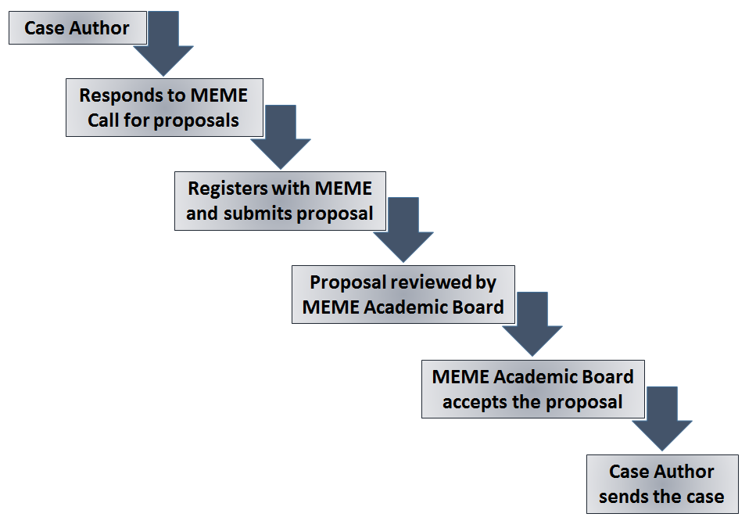
Figure 2: Steps to be followed for case submission
- Submission of the case study that provides an optimal learning experience
  - Once the Academic Board accepts the proposal, the Case Author prepares the full-length case scenario with all details, including the case-history, reports of all investigations, & all therapeutic interventions [where applied].
  - The Course author shall attach all the related files, containing any figures, tables, videos, X-ray pictures, ECG, EEG, etc. as applicable.
  - Case author shall prepare the text, tables and figures in accordance with the instructions given under ‘Preparation of Manuscripts’ (Annexure 3) below.
  - MEME operates a web-based platform for submission of the case study, and the Case Author can upload the case electronically in this online platform
  - In case the Case Author needs help with the electronic submission process, the MEME Instructional designer will guide him/her on the upload process; but should the Case Author be unable to take advantage of on-line submission, he/she can submit the work in an offline mode in the MS-Word format and submit it; then our resource-person will enter the case study into the online format.
  - Case studies that do not adhere to the following instructions will be returned to the Case Author for revision
    - Assignment of copyright (Annexure 4)
The Case Author shall assign perpetual and exclusive copyrights to all the material developed by him/ her to MEME for use in any form and distribution through any format or medium over any geographical area.
      - The Case Author shall bestow full rights of action, powers and benefits accruing, arising or belonging to MEME in relation to the said copyright absolutely. This includes MEME’s rights to modify, brand, co-brand, add value, combine with other works and re-purpose the assigned work in any manner so desired, including development of derivative works and products.
    - Warranty of Originality
The Case author shall pledge that (s)he has the full rights and absolute authority to assign the said copyrights. The Case Author shall also ensure that the copyright is free and clear from all encumbrances and claims, and the use of the said copyrights will not infringe any other third party’s copyright.

